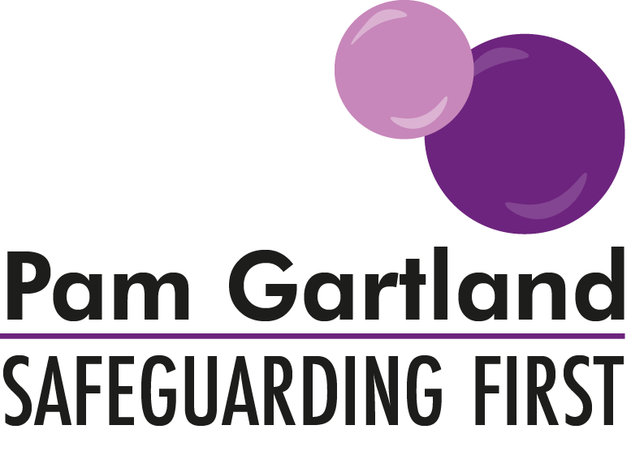

Visitor’s Leaflet

Following a number of Quality Assurance Visits, Safeguarding First have created this leaflet for visitors so that they understand in a visual way the expectations of them while on school site.

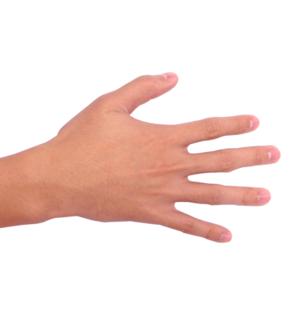
Our Responsibility to Safeguard
Safeguarding Children & Vulnerable Adults
Safe People

Safe Children

Safe Premises

What Health & Safety procedures do I need to be aware of while I am on site?
What can I do as a visitor to ensure that children are safe and feel safe?
Who should I speak to if I have a concern about someone’s conduct on site?
What policies or procedures do I need to be aware of whilst I am on site?
Who do I speak to if a child makes a disclosure to me? And where will I find them if I need them?

