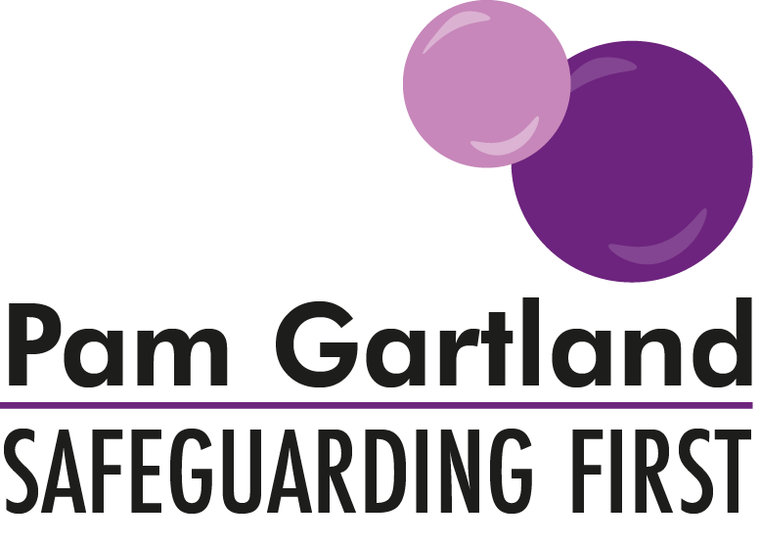
Safety Planning: Lesson Plan
Online Behaviour

Initial Discussion
Talk with peers about the types of things that you do online at home/school/free time etc?
E.g. Gaming, chat rooms, social media, videos e.g. YouTube

Main Discussion
Is being online a risky activity? What might those risks be?
What strategies do you put in place to keep yourself safe?
When we talk about this in school, do you use the lessons we learn and discuss and apply them when you are outside of school? Give examples
What are the big online issues at the moment e.g. cyberbullying? How do you deal with cyberbullying? Requests for personal information? Being groomed or radicalised? When does banter becoming bullying? Do you join in? Ignore? Report it?
Why do you think people’s behaviour online is more cruel, or different to how they may be in real life?
Have you ever behaved differently online than you would in real life and why?
Do you have difficulty in recognising the difference between the online world and the real world?
Why do you think that some people could be more vulnerable online than others e.g. Breck Bednar?
What would you do if you had concerns or worries about what someone else was doing online?
How could you help them?
Who would you talk to?
What would you do if you told someone and they didn’t do anything or believe you?
What would you do if that person pretended to adults that everything was fine but you still had concerns about their behaviour online?

Summary
Following the discussion today what impact has it had on your behaviour online?
What will you do differently?
How will you protect yourself and others in the future?

