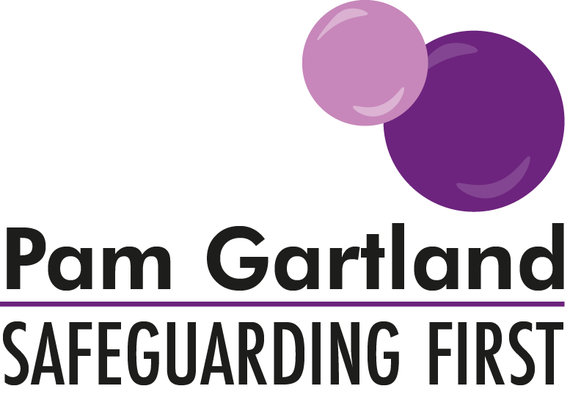

Safer Culture Questionnaire

PG:SF have produced this questionnaire for staff as a way of senior leadership gathering information about how safe and secure staff feel in school and how effective your school’s safeguarding culture is.

On a Scale of 1 to 10, (1 is poor/ineffective/unsuccessful and 10 is very good/effective/successful) Please ask staff to answer the following questions as honestly as possible and spend time at the end of each section elaborating on anything that has been scored 1- 4.

Name: ……………………………………….. Role in School:…………………………..

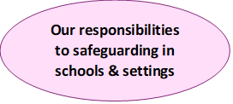
How effective is your school’s Child Protection Policy in giving clear expectations around managing safeguarding issues in school?
How effective is your Staff behaviour Policy in giving clear expectations to all staff about how to safeguard themselves and others both inside and outside of school?
How effective was your Induction Policy/procedure in giving clear expectations to you as a new member of the workforce?

How effective is governance in your school in holding senior leadership to account for the safeguarding of all pupils and staff?
How effective is staff’s involvement in the creation of policies?
Please discuss further anything you would wish to raise if you scored 1- 4 on any of the above.

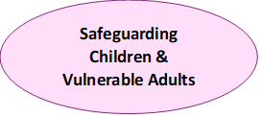
How well does your school support vulnerable children?
How effective is your contribution to safeguarding vulnerable children?
How effective is your whole school approach to safeguarding children?
How secure are policies, procedures, and practices in keeping children safe?
How safe do you believe students are in school by the support offered by staff?
How secure do you feel in dealing with a concern, worry or disclosure from a child?
Please discuss further anything you would wish to raise if you scored 1-4 on any of the above.

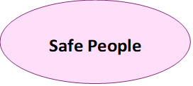
As a member of the workforce how secure do you feel in school?
How well does your school use the workforce’s views/ideas to shape policy?
How effective are staff’s voices in school in creating change?
How safe/secure would you feel in whistleblowing another member of staff’s behaviour?
How open is your school’s culture in approaching senior leadership with any concerns?
How effective is your school’s induction/re-admission process? (For new starters or returners from sickness or absence)?
How valued do you feel in school?
Please discuss further anything you would wish to raise if you scored 1-4 on any of the above.

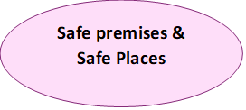

How effective is your current school risk assessment (pre/post covid) in keeping children safe in school?
How secure/safe is your whole site?
How secure and understood by staff are policy, procedures and practices/risk assessments in keeping you safe on site and off site?
How effective is staff’s contribution to site safety?
Please discuss further anything you would wish to raise if you scored 1-4 on any of the above.
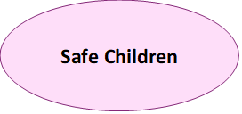
How effective is your school’s curriculum in sharing clear expectations with children about your school’s ethos and values?
How effective is your school’s curriculum in sharing clear expectations with children about sharing concerns/worries and contributing to a safe school?
How effective is your school in giving messages to children about building transferrable risks (i.e., applying skills learnt in school in how to keep themselves safe to situations outside of school)?
How effective is the whole staff workforce in contributing to the formal and informal curriculum of safety to all children in school as often as possible (e.g., conversations, debates, discussions at every opportunity to reinforce staying safe?)
Please discuss further anything you would wish to raise if you scored 1- 4 on any of the above.

Please ensure if there are any serious concerns raised in this questionnaire that you speak directly to the Headteacher/Chair of Governors.

