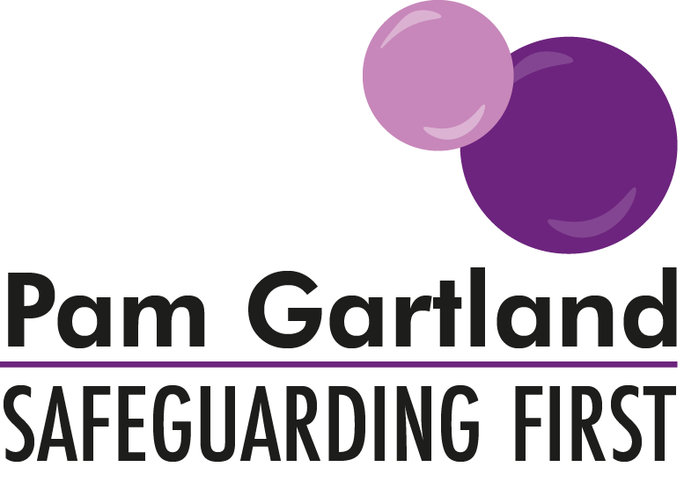

Safeguarding Policies for Schools

Safeguarding Children
Vulnerable Adults

- Child protection policy
- Attendance policy
- LAC policy
- SEND policy
- Behaviour & discipline use of reasonable force
- Anti-bullying and cyber bullying policy/online behaviour/expectations
- Administration of medication policy
- Information and communication policy
- Digital imagery policy
- Unaccompanied travel by children
- Arrivals and departures policy
- EVC policy
- Behaviour management policy
- Missing from education policy
- Mental Health and Well-being
- Bereavement Policy
- Weapons Policy
- Serious Violence
- County lines
Safe People

- Safer recruitment and selection policy
- Single central record
- Induction policy
- Staff behaviour policy/code of conduct inclusive of low-level concerns (Including remote/virtual working expectations/behaviour)
- Whistle blowing policy/confidential reporting policy
- Allegation management policy

Safe Premises

- Health and safety policy
- Asbestos procedures
- Legionella procedures
- Fire safety procedures
- PEEPs
- Key holding policy
- Work experience/additional learning environment policy
- Transfers of control agreements/lettings policies
- COVID-19 changes to premises

Safe Children

- Home school agreement policy
- Appropriate usage policy
- Online safety policy
- Individual risk assessments
- Intimate care policy
- SMSC/positive relationship/curriculum policy (inclusive of Fundamental British Values)
- Procedures that offer opportunity to hear the voice of the child
- Relationships and Sex and Relationships Education

