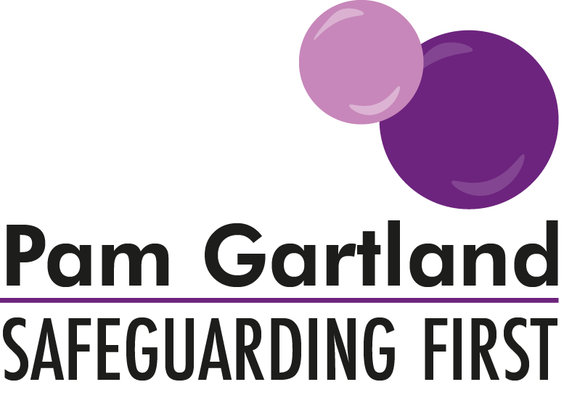

Safeguarding Effectiveness in School

PG:SF Ltd have produced the following questions for staff to complete following the annual reading of the Keeping Children Safe in Education document and review of the school’s current Child Protection Policy.

Alongside signing to say you have read the documents please use this quiz to support your knowledge and understanding of the expectations of Keeping Children Safe in Education.

- What are the main changes in the Keeping Children Safe In Education document this year?

- What impact or changes will it make in school?

- What are the acronyms CCE, CSE and FGM and what is your role in school around them?

- What are your main responsibilities in the Child Protection Policy in keeping children safe in school?

- Who are your DSL’s and how do you contact them when they are on or off site?

- When do you report something verbally to the DSL and when do you record it straight on to CPOMS/My concern?

- What should a good recording on CPOMS look like?

- Who do you whistleblow too and who might you report a niggle or ‘low level’ concern about adults to?

- What is a LADO and what is their role?

- What is the overall context of the local area and community your school is in and what impact does it have on keeping children safe in education?

