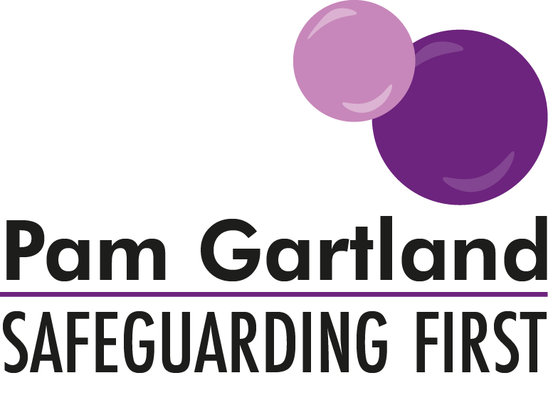

Risk Assessment Guidance for adults on site without DBS enhanced certificate check
including Students, Volunteers and Contractors

There may be some circumstances where there may be adults on your site without a DBS enhanced certificate. This may be new starters in roles within school awaiting this level of check, or people accessing your site without a DBS certificate in place (as their role does not warrant this level of vetting check). Please use this guidance to ensure all of the correct checks and balances are in place to ensure you keep everyone safe in your school.

Identity
You need to ensure that any adult entering your site, is who they say they are by presenting appropriate ID e.g. passport or driving license. It must be photographic ID. A letter from the service/college is not enough. The letter should correspond to the person’s photographic ID. If identification cannot be shown, you need to contact the company sending the individual to your site to agree what happens next.

Supervision
Any adult on site without a DBS enhanced certificate should be supervised. This means they should not have any direct or one to one access to a pupil without a member of staff (appropriately cleared) being present. In the instance of volunteers hearing children read, this should be in an open, accessible space, where a member of your workforce can observe and supervise the activity. Contractors should be isolated to the area of the school they are providing maintenance to and supervised by a member of staff (usually the site supervisor).

To have access to any part of the building e.g. toilets or staff room the adult must be escorted by a member of your workforce. It is therefore useful, particularly with maintenance work that this is carried out at times when pupils are not on site.
Identification badges/Lanyards
Consideration should be given to how best to identify the adults on site who require supervision. This could be a lanyard in a particular colour that allows staff and children to understand that an additional level of supervision is required for that adult.

Induction
Any adult accessing your site should be given a full and thorough induction. This should include health and safety, fire safety, lock down procedures, access to any relevant policies and recognition of the named designated safeguarding leads and how to access them.

Review
A review of the induction should be undertaken with the adult if they are regularly accessing your site for a sustained length of time e.g. student or volunteer. The impact evaluation from Safeguarding First could be used to support this review.

Next of Kin
It is necessary that for anyone regularly accessing your site e.g. volunteers, students that details of their next of kin are kept in the event of an emergency e.g. a medical issue. This ensures that appropriate support is available as soon as possible for the adult on site.

Safety of the staff
For any adult regularly accessing your site, it is necessary to know and understand any medical condition they may have including treatment or medication that may be required on site. So that the medication can be stored securely and safely on site as we would for pupils and not held within their valuables.
Mobile phones and personal belongings should comply with your current existing staff behaviour policy for all staff e.g. personal lockers or safe spaces and any adult on site must adhere to this (reinforced in induction).
Acceptable use policies should be signed up to including use of social media, smart watches and mobile phones etc.

This ensures the culture of vigilance is a shared commitment by all who work or visit your site.

