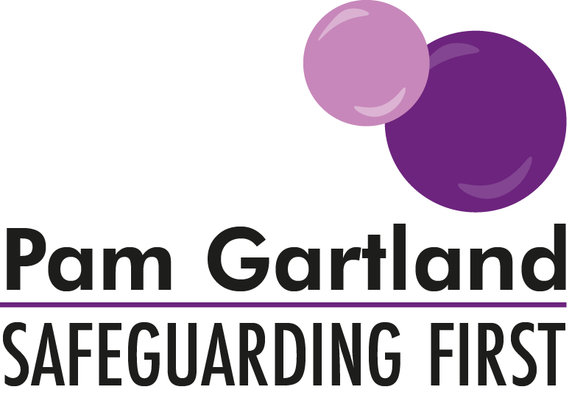

Quality Assurance Visits
Best Practice Advice

To support all schools and settings in the area of quality assurance visits, Safeguarding First has provided the following advice around the areas of the Safeguarding First Business Model (the bubbles) where we will spend our focus during our visits. This guidance is to support you prior to any visit we may undertake to your school and setting as well as support you in updating your safeguarding policies and practices in your school and setting in the meantime.

Our Responsibilities to safeguarding in schools and settings

Within this area of the quality assurance visit is the Quality Assurance document itself. The document is there to support schools and settings to ensure that all policies are up to date, ratified and signed and dated by the Chair of Governors and that any policies have been appropriately amended (e.g. the CP policy with the school’s logo and appropriate information inserted into the necessary areas).
It is important that all current policies are reflected accurately online via the school’s own website and match that held in the school or setting either electronically or in hard copy.
Also within this area is Governance of the school. During most visits that we undertake, we seek an opportunity to access and speak to the Safeguarding Governor or Chair of Governors. As part of that opportunity we will speak to the Governor around their understanding of safeguarding, how well that ethos is promoted within school and within the culture of school life and through leadership and management. We will also spend time, talking to the Governor about how they challenge safeguarding practice in school and how they ensure positive outcomes and effective change for children (see Governor Challenge Questions).

Safeguarding Children
Vulnerable Adults

From a visual point of view, within this area we will focus on how well known and signposted the Designated Safeguarding Leads are. For example, are the names and the photographs of the Designated Safeguarding Leads clearly visible in the reception area/staffroom/induction process/medication room/kitchen/dining hall? Do children and staff know who the DSL’s are?
Alongside this does the school hold an image of every child on site in the event of a missing or lost child scenario and the police requesting an image? When children have specific medical needs where are physical images of those children held? When children have a food allergy are those images of the children stored in the kitchen?
From a visual point of view, how well embedded is the culture of safeguarding and vigilance in school? E.g. display, views of adults, views of young people.

Do the policies the school/setting hold in safeguarding reflect every day practice? Is it evident that safeguarding is paramount here?

Safe People

Under this part of the quality assurance visit is the responsibility of staff in their conduct. From a visual point of view, how embedded and effective is the school/setting’s staff behaviour policy, e.g. dress code, conduct with children etc.? During the visit, Safeguarding First will look in random classrooms and will ask staff where personal belongings are stored. If these are not stored in lockers but held in the classroom, where are they stored? This will include where mobile phones/electronic devices are also stored.

Under staff conduct, how are playtimes and lunchtimes managed? E.g. are staff visible to children, what is the school/setting’s policy on hot drinks? Do staff move around freely to ensure full visual checks of the children on site? Are staff vigilant with children eating food/treats on the playground?

When services/individuals are accessing your site what checks and balances are made and how are they recorded? (Single Central Record) e.g. for commissioned services, do they hold enhanced DBS, employer liability insurance and public liability insurance and their own setting’s policies and procedures and are they appropriate?

Safe Premises

As part of safe premises, from the onset how safe is your site? Safeguarding First will monitor entry/exit onto site including any danger zones outside of the school. Upon entering your site, how secure is it? What checks and balances of ourselves are made and what information are we given about our safety, the safety of your site and general visitor information? How secure and robust are your signing in procedures?

Alongside visitors, how thorough is staff induction for volunteers, students and supply staff? What information is shared about the school day, processes, systems and individual children who may have learning, behaviour or physical needs? If children require PEEP’s, how is that information shared and managed as part of risk assessments when those young people are taken off site for visits or residential trips or for outdoor PE sessions?

How safely is medication stored on site? Where is responsive medication kept? How is medication transferred around school from classroom to classroom or managed during off-site visits or during PE Lesson?

How visible are your classrooms? Is there a clear and consistent display policy for classrooms and is it followed by all staff e.g. are windows and door panels visible not only for light into classrooms but for staff safety?
How proactive are staff in ensuring that broken or damaged equipment is reported immediately and for checking shared and communal areas for cleaning equipment e.g. cleaner cupboard/caretakers room, unlocked boiler or server areas etc.?

At break time and lunch time how is the selling/eating of fruit/tuck shop managed e.g. in the prevention of choking accidents?

Safe Children

Finally how effective is your school/setting in ensuring that children are safe and feel safe and how is this reflected visually and in the classroom? For example is there evidence of display work on issues to do with safety e.g. stranger danger, staying safe etc.? How do children know who to talk to and where to go e.g. staff members, peer mentors, bully buddies? What evidence is in your PHSE/SMSC and Health/Sex and Relationships curriculum that topical and sensitive issues are discussed and children and young people are given the opportunity to discuss anything that may concern them?

If children do not wish to seek out one to one opportunities, how else would they be able to seek advice? e.g., where are services signposted in your school and setting?

How involved are children in young people in managing their own risk and contributing to their own risk assessments for trips and visits as well as their own individual risks?

This guidance is by no means exhaustive in terms of the quality assurance visits we undertake however it covers the main areas we will identify. It is intended that as the parameters of safeguarding increase and the requirements of OFSTED alter that this guidance will be continually added to and updated.

