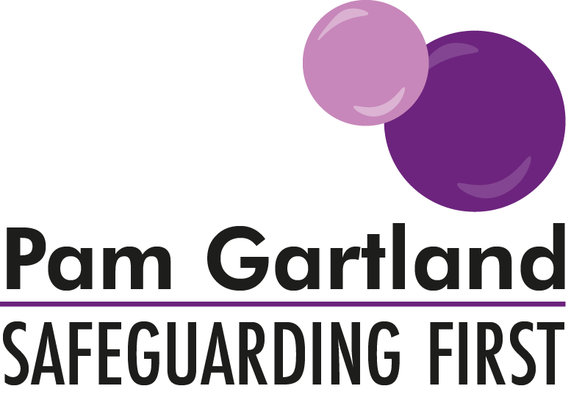

Internal Lessons Learnt
This proforma is to support you in establishing any ‘lessons to be learnt’ following any ‘near misses’ or serious incidents that have occurred on your site or in relation to your staff or children.
What and where did the incident occur? |  | Time and date of the incident:
Brief synopsis of the incident that has occurred:
Actions that were taken immediately: |  | Actions that did not occur:
Outcome of the incident:
What could/should have been done differently?
What was the impact of this on the child involved? |  | What was the impact of this on the adult involved?
Any further outcomes:

Learning from the event
From the incident/event what needs to change using the bubbles of safeguarding
Our responsibilities to safeguarding in schools & settings

What policies and procedures need to be reviewed immediately?
Safeguarding Children & Vulnerable Adults

What, if any is the immediate risk to the child? What intervention needs to occur to meet the individual needs of the child involved or for the rest of the pupils in the school/setting to secure their safety and well being? How will the child be supported going forward?

Safe People

What, if any is the immediate risk to staff? What intervention needs to occur to secure the safety and well being of all staff? How will the staff member be supported going forward? How will staff be briefed of any intervention following the incident/event?

Safe premises & Safe Places

What intervention is required to reduce the risk to the site? Is a health and safety audit required? Do site risk assessments need reviewing? Is a new walk around with Headteacher and Safeguarding Governor/Chair of Governors required? Are any adaptations to site or policies required?

Safe Children

What information needs to be shared with children? How can we use the curriculum to improve safety messages to children in this area? How are we continuing to promote transferrable skills?

Finally:
How do we measure the impact of any changes we have made?
When will we review this circumstance?
What difference has this review made?

