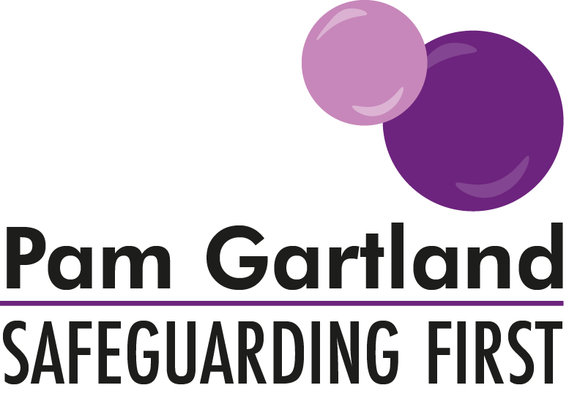

Parental Expectations and Guidance (Secondary)
In order for our school and staff to support your child in school we need the support from you as parents to allow us to help your young person to meet their full potential. We are offering some clarity for parents around our school expectations and ask you to show your commitment to your child’s education and well-being by working in partnership with us.

School Culture/ethos and role modelling
At our school our school culture is……… and our ethos is to treat all pupils, staff and parents with fairness and respect. We ask that as parents you support us in this and that if we have to make any challenges towards pupils or you as parents, it is in the best interests of the children. In the same way we expect that as parents you promote and role model our culture to your children at home. This means not acting to the contrary of any actions we take. For example if your child is given a consequence that you don’t undermine it or challenge our authority directly in front of your child. If you are unhappy with any decisions that are made we ask that you speak to us directly. This will ensure that our pupils experience consistency and understand clear boundaries both at school and at home.

School Rules
At school we have clear rules with high expectations for all of our pupils. This means that we expect parents to support their children in following them. Unless there are individual circumstances that would warrant an amendment to these rules then we expect all pupils to adhere to them. If we adapted these rules to accommodate all individual needs then we would not be consistent which is why we have such clear expectations. Although at times it might seem easier to adjust or ignore a rule in place, it undermines the school’s expectations of pupils and equally allows your child to have leverage to request to adjust or ignore that rule in the future or within your own rules and boundaries. Sometimes pupils may then feel that they can test the boundaries and equally ‘play adults’ off against one another. We would rather always work in partnership with you. Therefore if you are unclear on any of the reasons why we have such rules in place, please come and speak to us so we can have a joint approach with all of our children.

Uniform/Branding
Please ensure that you are aware of our school’s uniform policy and that it is adhered to. As soon as one pupil requests an adaptation then other pupils will follow. At school we have a uniform policy so that all pupils are the same and are not treated differently to anyone else. It also reduces the issues of peer pressure, reduces distractions and allows all pupils to feel part of our school family and be proud to wear their uniform and promote what our school stands for. With this in mind we request that parents are mindful of any branding such as shoes, coats, sports kits etc in addition to the uniform. The impact of choosing expensive brands creates competition between pupils to have ‘the best’, this in turn means some families cannot afford such additions and this widens the issue of peer pressure of which the uniform policy is trying to reduce. By maintaining this stance we hope to reduce the financial burden to parents and the demanding requests of pupils for the ‘next best thing’ and the increasing expectations from children. As a school we want to work in partnership with parents to reduce these increasing expectations of pupils.

Mobile Phones
At our school our mobile phone policy for pupils is… We ask that you ensure that your child is aware of this policy and understand when we take action because it has not been followed. Mobile phones are expensive technology and we cannot be held responsible for them getting lost, damaged or broken nor do we wish the use of them to be a distraction to our pupils’ education. Please ensure you support us in this expectation and sanction your children alongside us for its misuse.

Problem Solving and conflict
At our school we are working hard to create independence and resilience with our pupils and that means supporting them in gaining the skill set to be able to deal with their own problems. Although your child might come to you for advice/guidance and even to resolve a minor issue on their behalf, we ask that you support them in thinking of strategies to manage the situation (this does not mean in cases of bullying or any other serious incident of course we would want you to report those directly into school.) These strategies may involve speaking directly with staff or another child to resolve the matter. As parents we ask that if you feel speaking to the parent of another child (if the incident involves one) might be helpful, be mindful that this could escalate the situation and in turn make things more difficult for your child, particularly if social media is involved. At school we find that often young people can resolve things much easier than parents can and by stepping in this could impact on that.

Seeking support from school
At our school we have an open door policy where we would always encourage parents to come and speak to us about any matter. However we also have expectations about this.
Please ring to make an appointment with something that will require more time. Please do not attend our school and demand that you will be seen immediately by a member of staff. In a busy school this is not always possible.
Please remember you are role modelling your behaviour to your child, if they see you angry, distressed or upset then they may feel this is a strategy to dealing with a problem equally seeing you in that way causes more distress and anxiety for them.
Please come into school with your view of solutions. For example if an incident has occurred between two children OUTSIDE of school for example via social media, we will first ask you how you have already attempted to resolve it and this includes how you have encouraged your child to handle it and how you have dealt with it and how you think the situation can be moved forward. This is because it is has happened outside of school and also because we have clear expectations of behaviour from our pupils in school which can often be forgotten about outside of school.
Obviously as a school we would support you with any matter and work in partnership but we ask that you do not expect school to be able to resolve every matter without your own actions being taken into consideration. Our aim is to support you and your children in developing effective strategies to manage difficulties or problems without an over reliance on school. As a school our main role is to educate your children in a safe environment.

Communication
At school we have a variety of ways that you can communicate your views with school. We encourage and seek your feedback always. Please let us know that the communication is working and of any other ways it could be improved. At school we always encourage partnership working with parents and welcome your support, your views and improvements.

