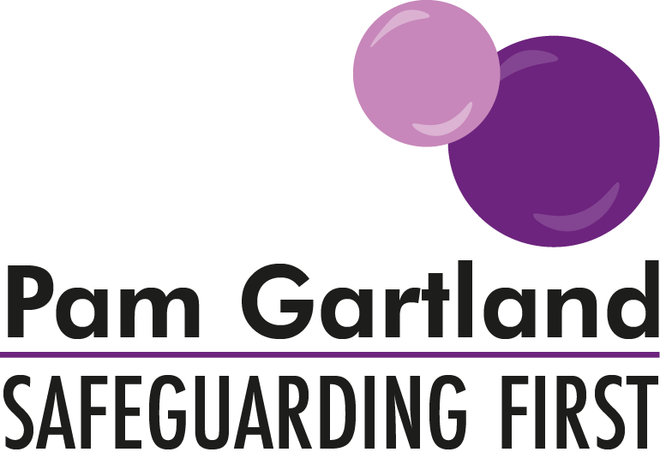

Mental Health Risk Assessment and Well-being Plan to support young people

Safeguarding First have produced this Mental Health Risk Assessment to support young people in the management of the mental health in the interim period of gaining medical and professional support and services. The Risk assessment should be used to support the young person as an ongoing tracker of their current circumstances and general wellbeing. Following the Risk Assessment, the school should complete a well-being plan with the child.

Risk Assessment
Child’s name and age
Underlying root causes- (Are there any ongoing or underlying root causes that have raised concerns about why the child/young person is displaying the behaviour now?) Consider here what efforts have been made to gain the child/young person’s voice and viewpoint.

What are the behaviours that the child/young person exhibits in school?

What are the triggers of the behaviour- e.g. does anything make the behaviour worse in school or outside of school that increases risk to the child/young person?

What are the strengths for the child/young person and family’s current situation? (i.e. what is working for the family already?)

What are the areas to improve? (What does this child/young person and their family still need support for?)

What does the child/young person want to see happen?

What would help the child/young person in school?

What are the agreed outcomes for the child/young person and how will the school to know that things have improved? (measurable outcomes)

Well-being Plan
Name: | DOB: | Year: | Risk Rating:
What are the behaviours I am displaying?

What if any risks are there of my behaviour? (including impact on others)

Triggers of my behaviour?

Safety Planning
What can help me in school? | What can help me at home? | What services am I engaged with currently? | What services am I waiting to engage with? | What can I do if I feel most at risk/in crisis?
What can safe adults do to help me? | What do I want to see change or can help me to feel better/cope better? | How can my family support me with this plan? | Miracle Question-If you could change one thing right now what would it be? | When will we next review this plan?

Consent: Does young person consent to share plan with parents/other agencies involved? Y/N

Signed (adult): Signed (young person): Signed (parent):
Date:
Review date:

