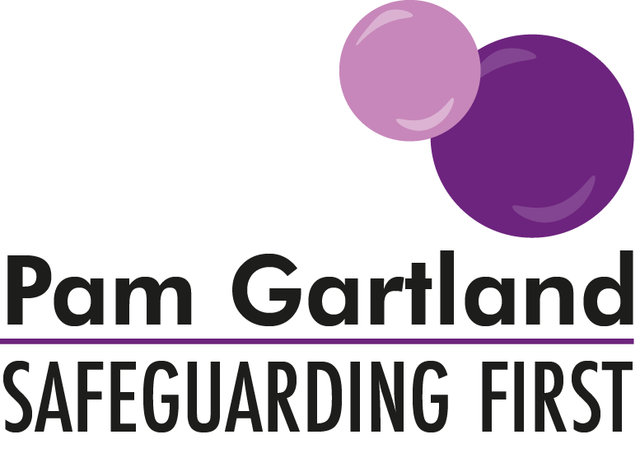

Making a recording using your school/setting’s system

In order to make an effective and consistent recording on either an electronic system like CPOMS or any other paper based system the following advice may be useful to consider and disseminate amongst the workforce.
Gathering the facts
Before any entry is made on an electronic system or on paper, it is important that all of the information recorded is accurate and relevant. Therefore all the facts and information should be at hand rather than a record being made without all of the pertinent information.
Firstly what needs to be considered is what has happened? Is it an event, a statement from a child, an incident, a telephone call? What are the facts around that? When did it happen? By whom was the information received or who undertook the action? Where did this occur e.g. particularly for a disclosure.
History - is there any useful history that can support the current incident or situation that is relevant to the record?
What statements were made and by which individuals and what was the context of this? Any direct statements/disclosures MUST be recorded WORD for WORD on to the record in speech marks.
Voice of the child
In any record that is made the voice of the child needs to be evident. What did the child/young person say about the incident/event? What are their views on the situation, the people involved, their feelings about what has happened? This can only be directly led by the child by open questions such as tell me what happened? Or how do you feel about that? It cannot be navigated or directed by the member of staff.
In every entry that is recorded every attempt should be made to gain the voice of the child, either directly or through play, writing or any other medium.

Making the Record
In every record that is made, there must be a PURPOSE, what were you doing and why? This should include the above (the facts and history where applicable). The record should then include any ACTIONS that need to be undertaken e.g. a subsidiary phone call, a report to a Designated Safeguarding Lead. There may be actions for the individual making the record and actions for the Designated Safeguarding Lead or Headteacher and this should be made explicit. The OUTCOME of the incident or entry also needs to be included. This should be how the incident ended, what was agreed with the young person? how did they feel? Was anything positive achieved? What was the summary of how things will move forward following on from what has happened?
Considerations
Every system may have its own idiosyncrasies and it is important that you fully understand how to use the system particularly for electronic recording. This means understanding each of the individual tabs and using them correctly. It is necessary that you also understand the need to record other individuals who were part of the report with full names and job titles (adults) and other children (you may choose to use initials or full names which can be redacted if records are required for court.
However tempting it might be to make assumptions, particularly if you have made a number of records on the same child, be careful not to write any entry as though the person reading already knows all of the history. For example an incident may have occurred last week and then another incident occurs this week be careful to correlate the two if required e.g. Following on from the incident on 01.10.2018, today Jonny repeated similar behaviours…. You have to remember that although the Designated Safeguarding Lead may remember the incident from the week before, to future proof your records you need to remember that other parties such as legal and the police may be reading them.
Training and consistency
In order for the records to continue to be as clear, accurate and consistent as possible it is important to have regular training intervals at least annually to ensure that the workforce is using the system in the same way. The training needs to review use of tabs and introduce or streamline existing tabs and challenge what and how staff record. For example classroom management incidents should not be recorded or reported as safeguarding issues.
Training should also look at who is using the system effectively and how frequently for example those with the most direct contact with children e.g. class teachers and teaching assistants should be logging incidents frequently. However that does not mean that those who do not see children as frequently would never record incidents.
Training on recording should be offered to those staff who have frequent contact with children but who may not have direct log on details to the system e.g. lunchtime supervisors. This is to ensure that all of the workforce knows how the system works and understands the importance of regularly sharing and recording concerns.

Recording Examples
Spoke to Ryan. Ryan said he didn’t like to live at home. He said now that his dad had left his mam she was upset all of the time and didn’t really do much at home.
This first example is not detailed enough and doesn’t give the reader an understanding of the context (where it was and under what circumstances) it is also not clear who spoke to the child and how the conversation began.

Miss Jones (teaching assistant) was listening to class 5 readers in the library. During Ryan’s one to one reading, he said to Miss Jones, ‘Now dad has left home, mam is upset all of the time. She doesn’t really do much with me at home.’ Miss Jones asked Ryan, ‘How do you feel about that Ryan?’, Ryan replied, ‘It’s ok she will feel better soon and it will go back to normal’. Miss Jones explained to Ryan that he could talk to any of the staff in school any time about how he felt. Ryan said he ‘felt better’ that he had talked to Miss Jones.
Miss Jones informed the class teacher of the incident, who advised she would speak to Ryan’s mam at home time to offer any support required.
This second example is much more detailed (although not verbose-it doesn’t need to be) but it explains the context, purpose, actions and outcomes.
These are crude and basic examples of recording and are used only to highlight the differences in the details that can often be lacking from workforce records. It is often those little details that get missed from records that can have a major impact on decisions that are made for children. It is important that all staff try to add as much detail to incidents that occur as possible.
Conclusion
This document is a basic guide to reviewing recording for consistency. If this outline can be shared with staff then the consistency of practice will improve. As always ensure that the need for good an accurate recording, never supersedes the need for discussion, interaction and face to face contact. Staff still need support in assessing risk, understanding the background of families and implementing (where they can) sometimes the first steps of intervention. The record must simply be the written word of the facts of the situation that happened and the actions that will be taken next to achieve the necessary outcomes for the child.

