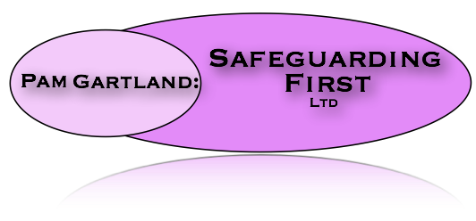

Information regarding child: Pen Picture

Brief chronology and history of events:

Child’s school history including: Attainment, Attendance and Behaviour

Important Issues to be aware of:

