Induction Impact Evaluation

Our responsibilities to safeguarding in schools & settings

What are the expectations of you from this policy, procedure or practice?
--------------------------------------------------------------------------------------------------------------------------------------
--------------------------------------------------------------------------------------------------------------------------------------
--------------------------------------------------------------------------------------------------------------------------------------
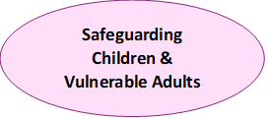
What is your contribution to keeping children safe in this school/setting?
--------------------------------------------------------------------------------------------------------------------------------------
--------------------------------------------------------------------------------------------------------------------------------------
--------------------------------------------------------------------------------------------------------------------------------------

What have you learnt from your induction that can support you in keeping children safe?
--------------------------------------------------------------------------------------------------------------------------------------
--------------------------------------------------------------------------------------------------------------------------------------
--------------------------------------------------------------------------------------------------------------------------------------

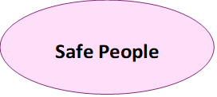
What is your role as a member of this workforce to contributing to a culture of vigilance?
--------------------------------------------------------------------------------------------------------------------------------------
--------------------------------------------------------------------------------------------------------------------------------------
--------------------------------------------------------------------------------------------------------------------------------------
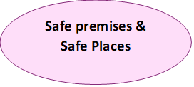
How can you help to ensure this school site is safe or support children in being safe outside of this setting?
--------------------------------------------------------------------------------------------------------------------------------------
--------------------------------------------------------------------------------------------------------------------------------------
--------------------------------------------------------------------------------------------------------------------------------------
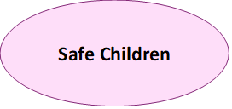
What can you do to help children through their formal and informal learning to help them to learn lessons on how to keep themselves safe?
--------------------------------------------------------------------------------------------------------------------------------------
--------------------------------------------------------------------------------------------------------------------------------------
--------------------------------------------------------------------------------------------------------------------------------------
Summary – What else do you feel you need to keep children safe?
--------------------------------------------------------------------------------------------------------------------------------------
--------------------------------------------------------------------------------------------------------------------------------------
--------------------------------------------------------------------------------------------------------------------------------------

