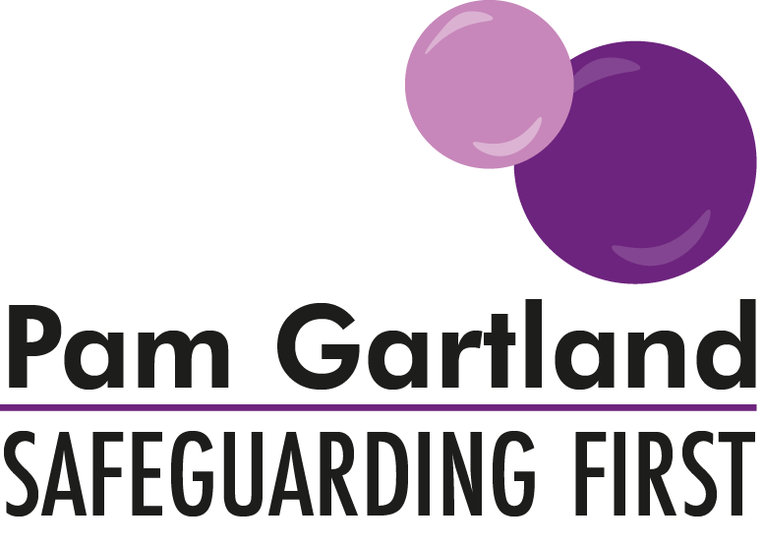

Guidance on Spiritual, Moral, Cultural and Social Policy development

- Consider how this can be embedded in your setting’s full curriculum through use of classroom based activities, school trips, assembly presentations, external agencies/visitors.
- Consider the different values, cultures and religions within your setting (bespoke to your setting) as well as the world wide community.
- Consider how this can be part of your anti bullying policy and other policies.
- Consider how you can evidence that you meet pupil’s needs in this area, e.g. activities, trips, circle time, displays, themed work etc.
- Consider how you see, hear and evidence the child’s voice/views in this area.

