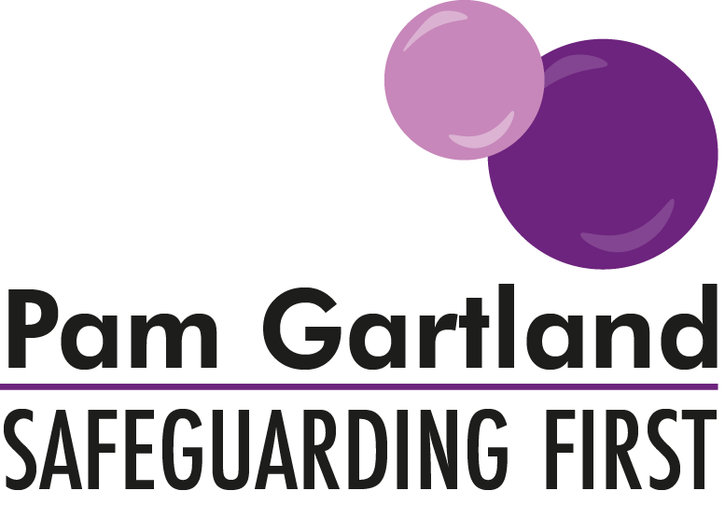

Guidance for Schools in Supporting Parents in Safeguarding

Schools regularly contact us for advice regarding supporting parents in managing difficulties that their children may be experiencing with other young people in their settings and how this can often overspill into the playground, the school and through inappropriate use of social networking sites.
We have written this guidance for schools to share with parents.

The playground/School Premises
The Playground/School Premises is a safe place for pupils and part of school property managed by the school. Please do not approach other children to resolve issues between that child and yours. Although you may feel angry, upset or frustrated by that child’s actions it is unacceptable and inappropriate to speak directly to that child in this way. You may make that child feel frightened, vulnerable or intimidated and you would not want your own child to feel this way. Please come into school and speak to us so that we could resolve the issue by speaking to both children involved and any others as there are always two sides to every story and in a safe and secure environment it is more likely that the children will tell the truth about what has happened and the issue can be solved.
Equally please do not choose the playground to resolve issues with other parents. Although you may feel that is a good opportunity to see the other parent those feelings of anger, upset and frustration can quickly lead into a confrontation (even unwillingly) and also can cause the other parent to feel the same way as you feel. This behaviour is again unacceptable and inappropriate particularly as it may be in front of your own and other children and can cause them to feel scared and anxious. Confrontations of this kind can often become physical and therefore you may increase the risk of harm not only to yourself but other children and this will lead to police intervention if it occurs on school property and we then have the legal right to request that you do not access our premises again. Please remember to come into school and speak to us and we can arrange an opportunity for you to discuss your concerns, perhaps even with the other parents involved in a calm and controlled environment so there is no risk of harm to you or to others.
If as parents you observe any of the above behaviours including parents behaving inappropriately towards their own children please inform us immediately.

Social Networking Sites
Social Networking Sites can be a good form of communication if used appropriately and a tool for positive learning for our young people. In school we support pupils in what it means to be a ‘good communicator’ for example by understanding ‘what is a friend?’ and how to maintain appropriate relationships online by being friends with only those people known to them. We also explore with our young people how to be kind to one another online and report any form of abuse or harm by recognising that by teaching young people this at an early age they will continue to make informed choices as they grow older and also recognise how to keep themselves safe online. In school we have cyber safety agreements and cyber safety policies that support this and as parents in our school community you have been part of this by signing our cyber safety agreement. We understand that parents have a differing level of knowledge of social networking sites and gaming sites and wide-ranging views on what their children should or should not be accessing, however there are some general tips to keeping your child safe online, these include;
Knowing what they are accessing.
Talking to them about how to stay safe online.
Setting parental controls.
Checking age-appropriate content of social networking sites and gaming sites accessed.
Checking the recommended age limit for sites accessed.
Children learn better through the role modelling of behaviour so please think about your own online activity including gaming sites or social networking sites and what message this can give your children. As highlighted above issues may occur between your child and others but please do not use social networking sites as a medium to address the issues with either another child or parent. Comments that are written online can be misconstrued, hurtful and distressing and once written can be used as evidence in police investigations. To prevent a situation like this occurring please come into school to address any problems that have occurred between children.
In line with this please do not use social networking sites to be critical of either the school or staff within the setting. If comments are made against the school or its reputation this becomes a legal matter and both legal services and the site used will be contacted to remove the communication as soon as possible. If comments are made against individuals working within the school which causes that individual hurt, alarm or distress then under the Malicious Communications Act 2003 this becomes a criminal matter and the police will be contacted immediately by the school.
These are the steps we have to take to ensure we protect our staff, governors and children in our school and community. Just as we take e -safety and bullying very seriously for the children in our school we also take seriously the communications adults in the community post on line.

Images and Photographs
Images and Photographs create good memories for both adults and children. However our school policy is………………………………………………
If you are taking an image using any mobile devices please ensure you that you take only photographs of your child unless you have the consent of the other parents. There are many parents who do not wish images to be taken of their child and there are legal reasons why some children cannot be photographed so please be respectful of this and our school policy. For that same reason those images should not be posted online. Images that are shared online become the property of the internet and the social networking site, open privacy settings will share your images with complete strangers and may in the future cause distress to your child because they were posted online. Please take this responsibility seriously. If school are made aware that images are posted online without consent legal and potentially criminal action could be sought.

