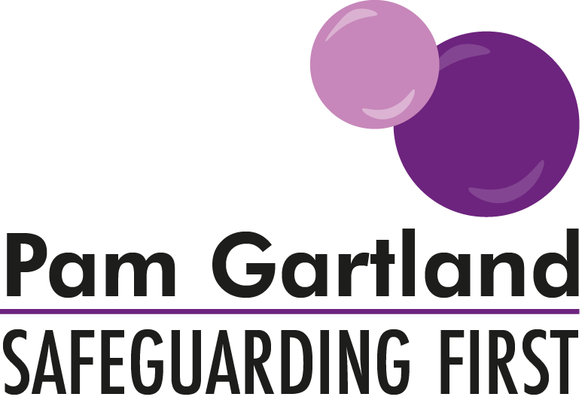

Guidance Note on School Trips and Residential Stays in Cities

In light of incidents of terrorism that have occurred within our country it is important to reflect objectively on any decision that you as a school or setting may have to make regarding any impending trips, excursions or residential visits that are planned.

In the first instance, regarding any planned trip it is important to ensure a robust and secure risk assessment is in place. If the planned trip has been undertaken before it is necessary to review all elements again and not just update the document. The risk assessment must be fully agreed by the senior leadership team and include the views of all parties involved. This means, children, parents and the staff who will be taking the children on the trip must be in full agreement of the trip taking place and feel confident in managing any potential risk. If this is not the case then it is important to review the trip to see if any amendments can be made in order for all parties to feel confident. For example, instead of choosing to walk to some of the sites it may be agreed that a bus tour is accessed instead. An effective way of doing this may be to invite parents, children and staff to meet together and discuss what assurances can be made. In making any such decisions it is necessary to contact the tour operator or travel advisor to ensure this is possible.

Further advice can be available from your local police or MP and you may wish to speak to your governing body before making a final decision.

The ultimate aim is to ensure that the trip can be as planned and prepared for as possible so that both staff, children and parents feel safe. Through a thorough risk assessment and strategic contingency plans in the event of an unassessed risk then the trip can continue to meet the needs of the children with the planned and agreed outcomes for their learning and life experience. In doing so, transparency and honesty with all involved is key.

It may be useful to have the following named individuals and their telephone numbers available on the risk assessment in the event that such support may be required.

Channel Panel SPOC
DFE counter terrorism (in the event that suspicious activity was witnessed)
Police (either 101 or 999)
LA safer partnership (if a maintained school)
Tour company
Travel Insurance

With any arranged trips or excursions or indeed any activity that occurs outside of the usual school day staff must consider the arrangements with parents for the collection of their children. A letter explaining all of the arrangements should be given to parents in advance of the trip/activity with an agreed outline of expectations of the hand-over of their children. Particular attention should be made if the collection time falls well outside of school hours or within the winter months both for primary and secondary phrase.
This information should be clearly detailed in your school prospectus/information given at children’s induction and should also form part of your staff behaviour policy, highlighting the expectations of staff in keeping children safe.

