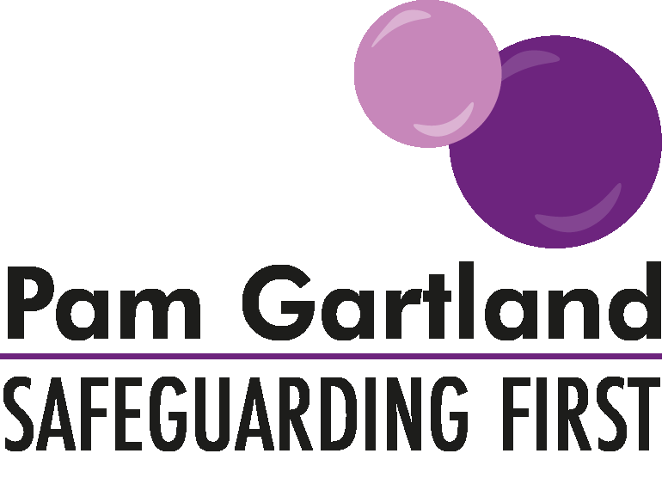

Governor Safeguarding Visit Checklist

For schools and settings who are requesting Safeguarding / Chair of Governors to undertake checks or visits to the school/setting/site with a safeguarding emphasis the below is a checklist under the Safeguarding First business model.

Our Responsibilities to Safeguarding in Schools and Settings
Is there a clear whole school approach to safeguarding and zero tolerance approach to child-on-child abuse?
What policies and procedures do we have in place? E.g., Arrivals and Departure, Child Protection and Child-on-Child Abuse.
How are they effective? E.g., What works well? How well are they understood by children, staff and parents?
Have they been observed working in practice? E.g., Watching arrival procedures or reviewing any near misses on CP Policy or effective practice with positive outcomes for children.

Safeguarding Children and Vulnerable Adults
What effective arrangements are in place to achieve measurable outcomes for children? E.g., scrutiny over numbers, data, SEN, vulnerable children?
Clear questioning over moving outcomes for children, preventing drift and delay in cases and keeping children safe.
What successful circumstances have led to improved outcomes for children (including educational outcomes) that can be recognised in data, progress, well-being?
What changes have been made in school to support vulnerable children? How have they contributed to it and how have other children contributed to changes in school to support others?

Safe People
How effective is the Staff Behaviour Policy? Checks on dress/appearance, gifts, classroom arrangements, mobile phones.
How secure is Single Central Record? All necessary columns, checks undertaken (use KCSIE), (Governors do not need to see full details but should check all the necessary columns from template are in place).
Is CPOMS/My Concerns recording effective and what impact does it have? Do staff follow procedures and learn from near misses?
Are staff prepared for OFSTED questions (see suggested questions in potential safeguarding questions for staff).
How effective is staff’s training inclusive of online training?

Safe Premises
What is the school’s commitment to KCSIE? e.g., evidence of posters/named DSL’s.
What can be observed on a site check, walk around? E.g., how secure is site? What changes have been made during COVID-19?
How effective are fire drills?
Have lock down arrangements been tested?
What can be observed in classrooms e.g., clear visuals, safe spaces, personal belongings out of the way?
How is medication provided and accidents recorded and managed?
Are attendance figures scrutinised?
How effective are meet and greet procedures?
Are TOCA/hire arrangements around child protection responsibilities in place and clear to all parties?

Safe Children
What can children tell governors about:
How safe their school is? What keeps them safe in school? Areas in school they feel less safe in? What is their school’s values and ethos?
What happens in the curriculum to keep children safe?
What transferrable skills can be demonstrated by children? How do we measure the impact?
Do children feel their views feelings are heard and valued in making changes to the school to ensure it’s a safe educational environment? How does this happen and how do you measure impact?
What understanding does the governor and children have about the community context, risks in the community and staying safe?
Is there synergy between children’s understanding of offline and online behaviours?
Are children taught effectively about safeguarding issues in the curriculum?
What impact has relationships/sex and relationships education had on children?

