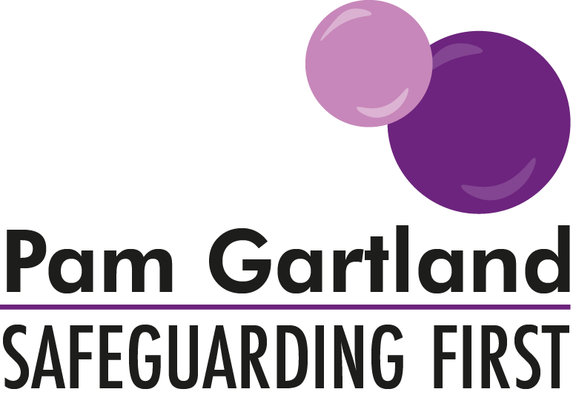

Chronology Audit
The purpose of a chronology is to record the regular day to day occurrences within the setting that have an impact on the well-being of that individual child and this may include any other events that occur such as contacts with parents or other professionals involved and any meetings that are attended and the outcome of them.

The audit tool below has been created for the purpose of quality assuring the content of chronologies to ensure that they are well maintained, fit for purpose and are of an agreed standard in line with other multi agency professionals.

***Please see the additional notes on what makes a good chronology prior to undertaking the audit.

STRUCTURE
Chronology |  | YES | NO | ACTION REQUIRED
1.1 | Chronology is on the front of the file visible to reader.
1.2 | Chronology is in standard format (e.g. Safeguarding First, LA).
1.3 | Chronology is clear and easy to read (either typed or handwritten)
1.4 | Chronology is signed and dated after every recording.
1.5 | There is evidence on the Chronology of who each staff member is and their designation in the setting (e.g. there is a key of staff members).
1.6 | Chronology is individual to each child (if there is more than one child in setting)
1.7 | Chronology identifies the status of the case (e.g. Early Help, CIN, CP or LAC.

CONTENT
Chronology |  | YES | NO | ACTION REQUIRED
2.1 | Chronology recording should detail WHO undertook WHAT actions and WHY and WHAT HAPPENED NEXT. Purpose, outcome, action.
2.2 | Chronology recordings are concise, factual and appropriate.
2.3 | Chronology recordings show no evidence of personal judgement or interpretation.
2.4 | Chronology recordings tell the story of the child and the involvement from the setting’s perspective and should be able to be followed by any new staff member (without gaps or the recorder making assumptions of pre-existing knowledge of the family)
2.5 | Chronology recordings should EVIDENCE what the event is (e.g. meeting/phonecall) and the OUTCOME.
2.5 | Chronology recordings should EVIDENCE the VOICE of the child (through an agreed recording method e.g. V stamps/highlighter every time child’s voice is evident)
2.6 | Chronology recordings should EVIDENCE any PROFESSIONAL DISAGREEMENT or RECONSIDERATION (including all actions take, who was spoken to and what happened next.
2.7 | Chronology recordings should EVIDENCE follow up e.g. steps taken from the setting to persist in contact regarding any matter, including professional disagreement or reconsideration.
2.8 | Chronology recordings should highlight any partnership working and the impact/outcome for the child
2.9 | Chronology recordings should highlight when any LEGAL ACTION has been taken and the outcome of this and what happened next.
2.10 | Chronology recordings should highlight any multi agency involvement e.g. SCR and the outcome and lessons learnt.
2.11 | Chronology recordings should highlight any AGREED TIMESCALES for events (e.g. response to referral, response to professional agreement) to ensure a process of follow up is in place.
2.12 | Chronology recordings should highlight any DRIFT/DELAY in cases and follow up action taken.

Signed………………………………………………………………..
Date…………………………………….
Designation………………………………………………………..
Signed………………………………………………………………..
Date……………………………………..
Designation………………………………………………………..

Actions to be reviewed on……………………………………………….

