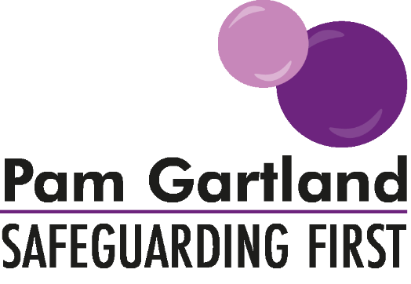

Alternative Learning Providers and Work Experience
Checklist

Alternative Learning Providers

 Single Central Record in place
 All staff working with children to have DBS enhanced certificate and barred list check
 Safer recruitment procedures in place and followed
 Named Designated Safeguarding Leads with appropriate training.
 Health and safety of premises confirmed (Use QA document)
 Appropriate policies in place: CP and Peer on Peer abuse, Induction, Health and Safety,
Whistleblowing/Confidential Reporting, Staff behaviour Policy (code of conduct/Safer working practices)

Work Experience Checklist

 DBS enhanced certificate for at least the co-ordinator in role (or appropriate risk assessment in place to ascertain placement is safe for Work Experience if organisation / business does not qualify for DBS enhanced certificate check.)
 Appropriate level of training for working with young people including dealing with a disclosure
 Safer recruitment procedures in place and followed
 Appropriate policies in place: Whistleblowing/confidential reporting, Health and Safety, Induction, Staff Behaviour Policy /Code of conduct/Safer working practices
 Appropriate agreement around level of supervision of student
 Appropriate code of conduct in place for students

