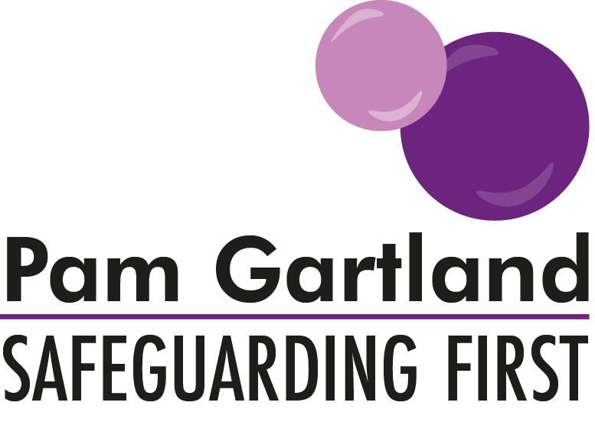

Advice/support in completing a Chronology

A chronology should incorporate the following:

- Be identifiable for all cases, either Early Help, Child in Need, Child Protection and Looked After Children.
- Each child should have their own individual chronology, if an incident is specific to a child and does not impact on another child it does not need to be repeated in each chronology.
- Should detail WHO undertook what ACTION and WHY, and WHAT HAPPENED NEXT. Don’t put initials of professionals in, full names are needed or it won’t make sense in the future and won’t make people accountable.
- Follow the process of recording a PURPOSE, an ACTION and an OUTCOME.
- Ensure anything you record including professional escalation has a conclusion.
- Clear, logical concise information about the child and its family.
- Identify key facts, contain no opinion or judgement. A professional opinion should be stated.
- Tell the story of the child so that someone who does not know the case could pick it up and understand the context of the situation for the child.
- Should reflect how the child feels and highlight the child’s voice in each action taken (e.g what was the impact for the child?)***
- Should highlight clearly any professional challenge or requests for re-consideration of the case by social care and what individual actions were taken to follow this up.
- Chronologies are often used in Court to establish a sequence of events and the work undertaken by professionals. Information must be put on the chronology sheet provided and follow on successive sheets as this can be used as evidence in Court.
- Chronologies can be sent as supporting documents when making safeguarding referrals and at child protection conferences and reviews.

***To demonstrate the voice of the child within your chronology please use the electronic ‘V’ stamp next to any recording you make that contains the voice of the child, for example any direct discussion, any comments made by the child and observations that the reflect the child’s views.

