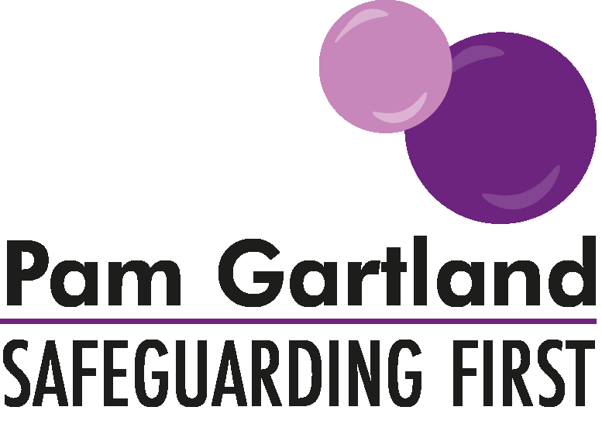

Making The Most Effective CP Plan

When participating in the making of CP plans or being part of any multi agency group in formulating an action plan, it is important to ensure that the plan is fit for purpose. This means that the content of the plan is both measurable, contributes to improvement for the child or children and measures parent’s ability to be able to make and sustain changes of their own accord during a period of service intervention.
Therefore the below questioning is to serve as a prompt to ensure that as part of a multi- agency team you are contributing to making the most effective plan as possible.
Creation of the plan
- Is the plan individual to the child, i.e. not a family plan and considers what that particular child requires.
- Is the outcome of each contribution the first thing that is considered? i.e. what do we expect to see change rather than a task list of what parents need to do?
- Is there an even balance of contribution between all agencies offering support and also expectations of parental change?
- Is there clarity on who is contributing to each change and how that change will be measured e.g. school attendance - has this improved due to school support/input or parents actively improving school attendance?
- Is the plan fit for purpose? Does it cover the issues outlined in the conference? Does it measure risk as well as safety networks? Is it achievable and is it ordered in terms of what we want to see change first?
- Use the plan at each meeting to measure the change, improvements, and to hold parents to account.

Services providing intervention
- If services are going to be provided, what are they and what do they offer? E.g. Drugs services - what is their scheme of work, what does it involve, how many sessions, over what timescale and does it involve testing?
- What assessment will be undertaken with the parents or child at the beginning and what assessment will be undertaken with the parents or child at the end of the sessions? E.g. How will progress be measured? Attendance at the sessions is not evidence of improvement.
- How has motivation, commitment, changing mindset, recognising risk taking behaviour, causal links between childhood experiences and impact on parenting been considered?
- What are the triggers, behaviours and risks associated with their difficulty/problem e.g. substance misuse?
- What are the contingency plans, back up and networks available with lapses or risk taking behaviour?
Parenting assessments
- What will the parenting assessment be looking at?
- What will be measured over time? What analysis of background, parents own childhood and experience of childhood will be looked at?
- What motivates parents to change? What is their understanding of the CP process? How do they want things to be different and to improve for their children? What connections can they make to how they were parented to how they parent their children?
- How do parents view any difficulties they have e.g. drug or alcohol misuse impacting on their parenting and how do they manage this?
- What are parent’s views at the end of the assessment or service intervention? Has their parenting style changed? Do they recognise risk in their behaviours and how it can impact on their parenting?
Plans that have been in place for 18 months +
- What has contributed to the lack of progress? E.g. drift, delay, change in staff?
- What professional challenges have already been made and documented?
- What needs to change in order for the plan to be successful? E.g. consistency in staff, parent’s commitment or motivation.
- If the issue is drift and delay - what strict plan with clear timescales can be put in place to ensure progress and measurable outcomes and when will it be reviewed?
- If the issue is parent’s progress - what evidence-based practice is there that parents are unwilling or unable to make and sustain necessary changes?
- What is the next course of action and what is the timescale for that?
- What immediate intervention is needed for the children around the ongoing risk of significant harm e.g. family, kinship assessments, court, public law outline etc.
- Is the line manager and IRO fully aware of concerns raised by professionals around lack of progress or ineffectual plan?
- What professional intervention is in place e.g. formal professional disagreement and at what stage?

