**My change plan**

What do I want to change? 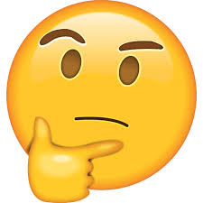

Name: ……………………………………………………………………

What three things do I need to do?

1

3

2

What will help me? 

Who can help me? 

How do I feel about achieving my plan?

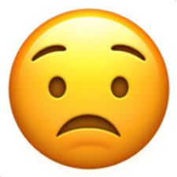

What have I done in 2 weeks?

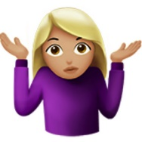

How do I feel about my progress?

6 Months

2 Months

4 Weeks

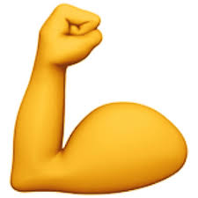

When I achieve my change, what will help me maintain it?

If I don’t achieve my change, what will help to motivate me? 