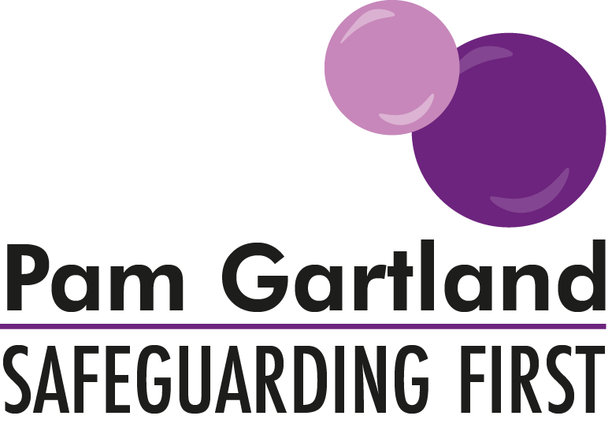

Safety Planning for Young People
Safeguarding First have produced this safety plan to support young people who may be engaging in risk taking behaviours to keep themselves safe. The plan should be developed with the young person and their consent as well as consideration to the young person’s parent and other agencies involved with the young person. The plan considers the behaviour, the risks, the triggers, any particular or specific issues (two examples given) and the safety planning.
This plan can be adapted and edited for your own use and is by no means exhaustive. It helps the young person to focus on what is happening, why and the plans and strategies of intervention to keep the young person as safe as possible.
My Safety Plan
Name: | DOB: | Year: | Risk Rating:
What is the behaviour? | How often?  How long?  How do I get there and back? | Where do I engage in this behaviour? | Who do I engage in this behaviour with? | Why do I engage in this behaviour?
Risks of my behaviour? (including impact on others)

Triggers of my behaviour?

Specific Issues
Substance misuse: | How much am I using? | What happens when I stop using? | How will someone know that I am safe e.g. who checks on you?
Sexual behaviours/exploitation: | Is more than one person involved? | Am I using protection from STD’s and pregnancy? | Do I feel like I can say no?
Safety Planning
How can I keep myself safe? | Where is my nearest safe place? | Who is my nearest safe friend? | Who can I get to call me at a certain time to check that I am ok?  What can our shared word/phrase be if I need them to help me? | What strategies can I put in place if I feel like I am at risk?
What strategies can I put in place if I feel like I am at risk? | How can I make safe choices? E.g. offered alcohol, drugs, sex? | What is my understanding of consent? | What would help me to say no if I needed to? | Who can I talk to about what is happening?
What would (if anything) prevent me from engaging in this behaviour? | What plan can I put in place to stop this behaviour if I want to?

Consent: Does young person consent to share plan with parents/other agencies involved? Y/N

Signed (adult): Signed (young person): Signed (parent):
Date:
Review date:

